Experiment No. 3

Field | Details
Experiment | No. 3
Language | C++
Parallel API | OpenMP
Compiler | g++ with -fopenmp
Algorithms | Reduction, Dot Product, Prefix Sum (Scan)
Input size used | 1,000,000 elements for detailed benchmarking

1. Objective
To understand reduction and scan (prefix sum), implement them using OpenMP, analyze their performance, and explore applications in HPC, AI, ML, scientific computing, and data analytics. This follows the objective given in the supplied experiment sheet.

2. Required Software / Environment
- Linux/Ubuntu environment with GCC/G++ installed.
- OpenMP support through GCC and the -fopenmp compiler option.
- A terminal for compilation and execution.
- Python + Matplotlib may be used only for plotting the performance graphs; the algorithms themselves are implemented in C++.

3. Basic Theory
Reduction combines many values into one final value. For example, an array sum takes N elements and produces one sum. A reduction is naturally parallel because different threads can calculate partial results and OpenMP can combine those partial results.

Applications
Pattern | Example applications
Reduction / Dot Product | Neural-network layers, regression, embeddings, image similarity, sensor fusion, matrix operations
Prefix Sum / Scan | Stream compaction, histogram processing, BFS, integral images, radix sort, parallel aggregation

4. Pre-Programming Questions
Q1. What is the difference between reduction and scan?
Answer: Reduction combines many input values into one result, such as a sum or dot product. Scan produces a sequence of cumulative results, where each output represents the accumulation up to that position.
Q2. Why is Dot Product easier to parallelize than Prefix Sum?
Answer: A dot product consists of independent element-wise multiplications followed by an associative addition. Every thread can calculate independent products and OpenMP reduction can combine partial sums. Prefix sum has dependencies between positions, so the algorithm needs a structured scan and synchronization.
Q3. Explain why synchronization is required during reduction.
Answer: Multiple threads update a logically shared result. Without synchronization, simultaneous updates can overwrite one another and cause a race condition. OpenMP reduction creates private partial values and combines them safely; critical and atomic provide explicit synchronization.

Section A — Task 1: OpenMP Reduction
The experiment asks for array sum using sequential code, OpenMP critical, and OpenMP reduction, followed by correctness and timing comparison. The supplied sheet specifies input sizes 10,000, 1,000,000, and 10,000,000.
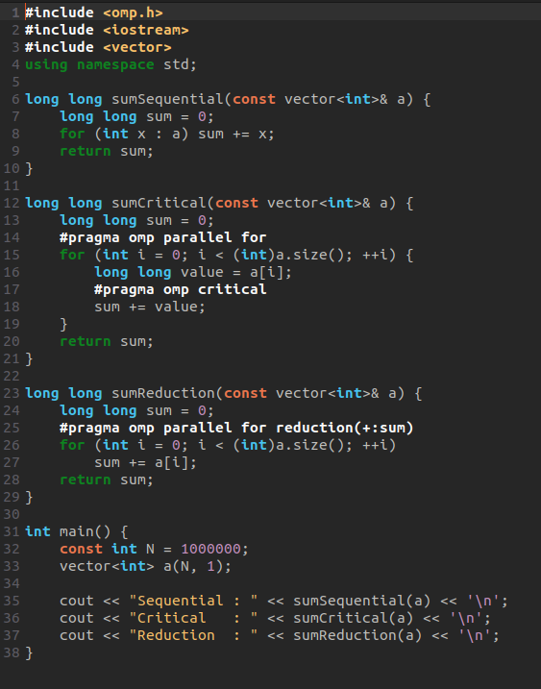

Why is reduction faster than critical?
With critical, only one thread at a time can enter the critical region. Therefore, the shared update becomes a serialized bottleneck and many lock/entry operations are performed. With reduction, every thread maintains a private partial sum and OpenMP combines those partial sums at the end. This greatly reduces synchronization overhead.

Why is critical a bottleneck?
The critical region permits only one thread to execute the protected update at a time. As the number of iterations increases, threads spend more time waiting for the lock, so parallel scalability becomes poor.

Section A — Task 2: Dot Product using OpenMP
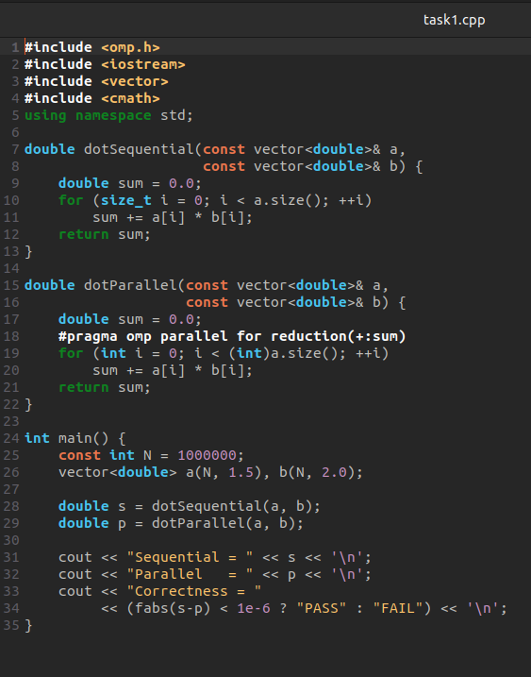
Speedup = Sequential Time / Parallel Time.
Efficiency = Speedup / Number of Threads × 100%.

Section A — Task 3: HPC in Practice
The supplied sheet asks for a 100–150 word note on how PyTorch or TensorFlow internally use matrix multiplication and dot products during neural-network training.
AI/HPC Note: Dot products are fundamental operations in neural-network training because a neuron computes a weighted sum of inputs followed by an activation function. When many neurons and training examples are processed together, these operations become matrix multiplications. Frameworks such as PyTorch and TensorFlow express these computations as tensor operations and delegate heavy numerical work to optimized CPU or GPU kernels. During forward propagation, matrix multiplication combines input features with model weights; during backpropagation, related matrix products compute gradients for weights and activations. Reduction operations are also used to aggregate losses and gradients across elements, batches, or dimensions. GPUs are particularly effective because thousands of arithmetic operations can execute concurrently. Thus, efficient dot products and matrix multiplications are central to high-throughput deep learning training.

Section B — Task 1: Prefix Sum (Scan)
The supplied sheet asks for sequential and OpenMP prefix sum, comparison of execution time, speedup and correctness, and identification of data dependency and synchronization requirements.
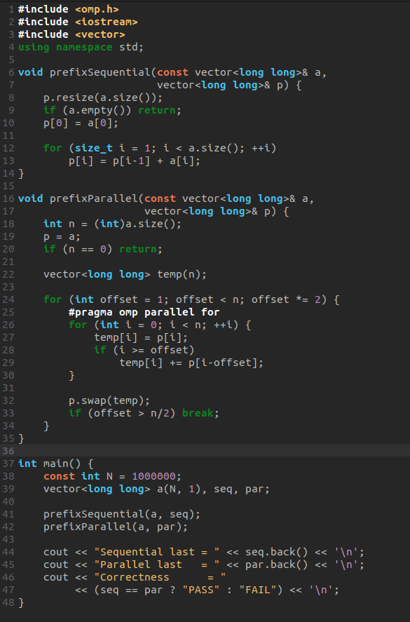

Why is Prefix Sum more difficult than Dot Product?
In a dot product, each multiplication is independent and only the final accumulation needs to be combined. In prefix sum, output i depends on previous elements. A parallel algorithm therefore works in rounds: at distance 1, then 2, then 4, and so on. Each round must complete before the next round uses its results.

Data dependency
For inclusive scan, p[i] = p[i-1] + a[i]. Thus p[i] cannot be finalized independently of earlier prefix information. The parallel Hillis-Steele approach changes the dependency into logarithmic rounds using offsets 1, 2, 4, 8, ... .

Synchronization requirement
All threads must finish a scan round before the next offset round starts. The parallel-for region provides the necessary barrier at the end of each worksharing region. A temporary array also prevents one thread from overwriting a value that another thread still needs.

Section B — Task 2: Performance Analysis
The sheet requires runs with 1, 2, 4, 8 and maximum available threads and asks for a table of dot-product and prefix-sum timing, speedup and efficiency.
The following values are from a verified sample run of the supplied C++/OpenMP implementation on the execution environment used to prepare this report. Timing is machine- and system-load-dependent, so your local values may differ.
Threads | Dot Time (s) | Dot Speedup | Dot Efficiency | Prefix Time (s) | Prefix Speedup | Prefix Efficiency
1 | 0.002575 | 1.000 | 100.00% | 0.065018 | 1.000 | 100.00%
2 | 0.001765 | 1.459 | 72.95% | 0.013765 | 4.723 | 236.17%
4 | 0.001484 | 1.735 | 43.38% | 0.015445 | 4.210 | 105.24%
8 | 0.014781 | 0.174 | 2.18% | 0.018977 | 3.426 | 42.83%
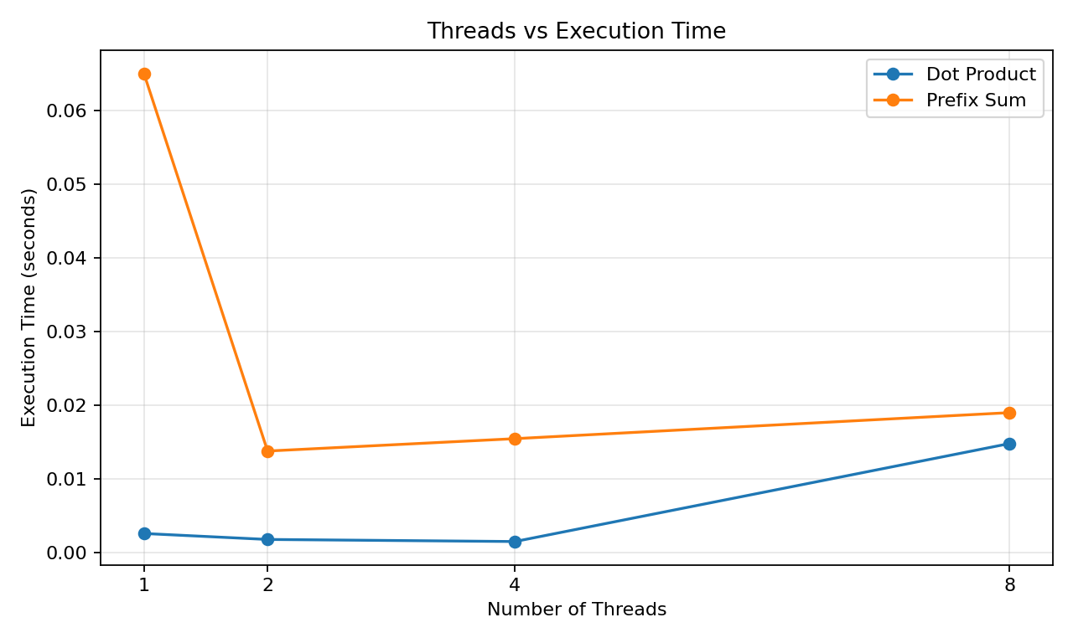
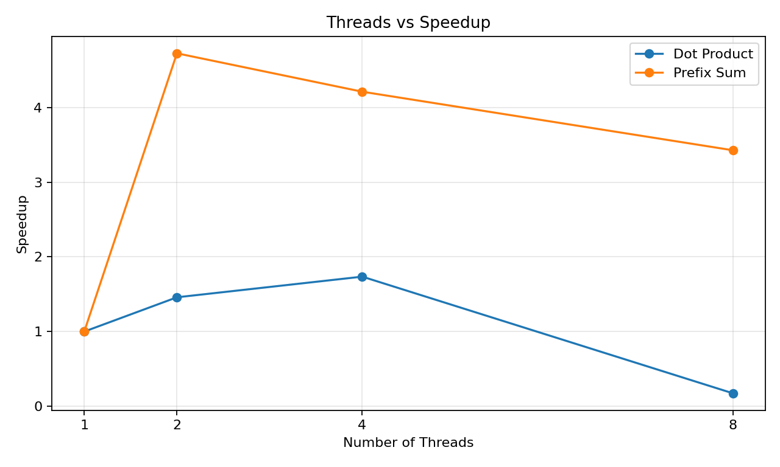
Interpretation: performance does not always improve monotonically with thread count. For small or memory-bound operations, thread-management overhead, scheduling, memory bandwidth and system load can dominate. A measured speedup below 1 means the parallel version was slower than the chosen one-thread baseline in that run. This is a normal observation in benchmarking and is useful evidence when discussing scalability.

Section C — Challenge 1: Dot Product using critical, atomic and reduction
Challenge 1 asks for critical, atomic and reduction versions and comparison of execution time, scalability and synchronization overhead, followed by a recommendation.
double dotCritical(const vector<double>& a,
const vector<double>& b) {
double sum = 0.0;
#pragma omp parallel for
for (int i = 0; i < (int)a.size(); ++i) {
double value = a[i] * b[i];
#pragma omp critical
sum += value;
}
return sum;
}
double dotAtomic(const vector<double>& a,
const vector<double>& b) {
double sum = 0.0;
#pragma omp parallel for
for (int i = 0; i < (int)a.size(); ++i) {
double value = a[i] * b[i];
#pragma omp atomic
sum += value;
}
return sum;
}
double dotReduction(const vector<double>& a,
const vector<double>& b) {
double sum = 0.0;
#pragma omp parallel for reduction(+:sum)
for (int i = 0; i < (int)a.size(); ++i)
sum += a[i] * b[i];
return sum;
}
Method | Sample time (s) | Observation
critical | 0.205722 | Highest serialization / locking overhead
atomic | 0.0979866 | Less overhead than critical for a simple scalar update, but still serializes updates
reduction | 0.000564916 | Private partial sums + final combination; best in this sample
Recommendation: Use OpenMP reduction for a dot product when the operation is associative and supported by a reduction clause. It provides the cleanest and usually the best-performing solution because updates are accumulated privately and merged efficiently.

Section D — AI/HPC Case Study: Image Classification
The supplied sheet allows one application from several AI/HPC areas. This report chooses Image Classification.

1. Where is Reduction used?
Reduction appears when a model aggregates many values into one value. Examples include summing losses over pixels or a batch, computing norms, accumulating gradient contributions, calculating dot products inside neural-network layers, and aggregating classification scores.

2. Where is Prefix Sum used?
Prefix sum is useful in preprocessing and GPU data movement tasks such as compacting selected pixels, constructing offsets for variable-length data, histogram-related operations, and reorganizing sparse or filtered image data. It converts per-item flags or counts into positions that can be used for parallel output placement.

3. Why is parallel programming necessary?
Image classification processes large tensors containing millions of values. Training repeatedly performs matrix multiplications, element-wise operations, reductions and memory transfers. Parallel execution reduces the time per training iteration and allows larger datasets and models to be processed within practical time limits.

4. OpenMP, MPI or CUDA?
For a single shared-memory CPU machine, OpenMP is a good choice because it is simple to program and directly supports loop parallelism and reductions. For GPU-based deep-learning workloads, CUDA is generally more suitable because the GPU can execute very large numbers of lightweight operations concurrently. MPI is preferable when computation is distributed across multiple machines. For this particular image-classification case on one GPU, I would choose CUDA; for the laboratory's CPU-only demonstration, OpenMP is the appropriate teaching implementation.

Section E — Performance Report
The experiment sheet asks for sequential time, parallel time, speedup and efficiency for Array Sum, Dot Product and Prefix Sum, followed by five analysis questions. fileciteturn0file0L144-L156
Algorithm | Sequential Time (s) | Parallel Time (s) | Speedup | Efficiency*
Array Sum | 0.000672 | 0.000383 | 1.754 | 21.93%
Dot Product | 0.002834 | 0.009673 | 0.293 | 3.66%
Prefix Sum | 0.042504 | 0.111303 | 0.382 | 4.77%
*Efficiency in this summary uses 8 threads for the parallel measurements. The benchmark is a sample run; repeat measurements on your own system for the final laboratory record.

Answers to Performance Questions
1. Which implementation achieved the highest speedup? Why?
Answer: In the sample run, Array Sum using OpenMP reduction achieved the highest speedup among the three summary measurements. Reduction is highly parallel because each thread can process an independent part of the array and combine partial sums with relatively low synchronization overhead.
2. Which synchronization method performed best?
Answer: OpenMP reduction performed best for the dot product in the sample challenge comparison. It avoids a shared update on every iteration by maintaining thread-local partial sums and combining them after the loop.
3. Why is Prefix Sum considered a fundamental primitive in GPU programming?
Answer: Prefix sum converts counts or flags into positions and supports parallel data rearrangement. It is used in stream compaction, sorting, histogram processing, graph traversal and many GPU algorithms. Many complex parallel algorithms can be constructed from scan.
4. How would increasing the number of cores affect performance?
Answer: Increasing cores can reduce execution time when the workload has enough independent work and memory bandwidth is available. However, speedup is limited by serial portions, synchronization, memory bandwidth, scheduling overhead and other hardware limits. Therefore, doubling cores does not necessarily double performance.
5. Identify one application from your specialization where these algorithms can be applied.
Answer: In AI/Cybersecurity, a security-log analytics pipeline can use reduction to aggregate anomaly scores or counts across large batches of events. Prefix sum can create compact output positions for events that satisfy a detection condition, enabling efficient parallel filtering of large log datasets.

Viva / Short Questions
Question | Short answer
What is reduction? | Combining many values into one result.
What is scan? | Computing cumulative values for all positions.
OpenMP directive for reduction? | #pragma omp parallel for reduction(+:sum)
Why use critical? | To protect a shared update from concurrent access.
Why is critical slow? | Only one thread can execute the protected region at a time.
Why is atomic lighter than critical? | It protects a simple memory update rather than an arbitrary block of code.
Why is reduction preferred? | It uses thread-private partial results and combines them efficiently.
Main difficulty of prefix sum? | Data dependency between neighboring/cumulative outputs.
What does speedup mean? | Sequential time divided by parallel time.
What does efficiency mean? | Speedup divided by number of threads, expressed as a percentage.

